[The Covid-19 Risk Monitor and Recommendation App](https://codeinspace.co/)

Project Design Document

and steps taken to implement it

Code in Space

participant of

NASA SPACE APPS COVID-19 HACKATHON CHALLENGE 2020

The Earth, 31.05.2020

1. **Problem determination.**

Before describing the solution we came up with, we need to give a brief overview of what exact problems we are trying to solve.

We make our predictions on the basis of “*A meta analysis of prevention and control measures aimed at COVID-19 spread control*” we did - please refer to it for scientific rationale.

**Problem 1.** Many measures and policy responses to the coronavirus pandemic taken by countries during the first half the year of COVID-19 pandemic have lead to certain results - some of policies were more effective, other ones showed less results. Effectiveness of the measures taken should be analysed and taken into account in planning further actions. As for now there are many studies being made, but due to absence of a single meta analysis of global and local policies` effectiveness further planning is being rather difficult.

Measures have shown short term results at an expense for great economical losses - thus, more stable long-term solutions shall be developed.

**Problem 2.** Lack of coordination between countries makes individual countries` efforts less stable due to existing possibility of the virus coming back. Alongside with development of more stable and cost effective measures as described at Problem 1, a single tool could be developed for use by local governments and international organizations. The functionality of the tool shall allow real time access to data on disease spread in a given country and in the world, modeling and prediction capabilities and, what's more important, access to auto-generated recommendations to local governments on policies to implement, based on local conditions.

Altogether such technologies will make a single place for decision making, but on the basis of local needs.

**Problem 3.** At the given moment, there is no vaccine or concrete recommendations on drug treatment. Policies remain the only tool to control disease spread.

Thus, measures and policies shall be optimized to allow countries to apply them as long as it is needed to develop sustainable medical solution, without suffering great losses to global economies.

1. **Project idea.**

After the problems are determined, we need to set the general idea of our solution. As we have mentioned in Problem 2, a tool could be made to facilitate timely response by the local government on changing situations in their countries.

We came up with “*The Covid-19 Risk Monitor and Recommendation App*” - the tool for local governments to quickly analyze the potential of an outbreak and what response measures are appropriate for their conditions. Data from global sources is aggregated and analyzed to show best practices in virus prevention and containment based on the level of risk. Quick access and visualization will improve decision making. Local conditions, like population density, climate, air pollution and economical state should be taken into account to let policy makers auto - generate the most optimized policies for controlling spread of covid relevant to their local countries and communities.

__________________________________________________________

SYNOPSIS OF A TOOL

A SOFTWARE FOR LOCAL POLICY MAKERS

FEATURES: REAL TIME ACCESS TO CURRENT CONDITIONS OF A COUNTRY (ECONOMY, POPULATION DENSITY, ENVIRONMENT)

ANALYSIS OF AVAILABLE POLICIES AND RATES OF THEIR EFFECTIVENESS

ANALYSIS OF APPLICABILITY OF POLICIES TO LOCAL CONDITIONS

CREATING PREDICTION MODELS FOR DISEASE SPREAD

AUTOMATIC GENERATION OF CONCRETE POLICIES TO IMPLEMENT

__________________________________________________________

*This tool will be able to address* ***Problem 1*** *and, if scaled to the level of international organisations like the WHO of the UN,* ***Problem 2.*** *That, eventually, will give the countries an opportunity to implement long-term solutions and policies, thus having enough time to develop vaccine and treatments, thus,* ***Problem 3*** *is also addressed.*

1. **Design of a prototype**

The task is monumental. We should make basic assumptions first and then try them out. If succeeded - put it into a prototype solution. Develop further.

Our assumptions during the 2020 NASA HACKATHON were the following (based on our meta research):

1. Some policies are more effective than others;
2. Exact conditions of a given country makes impact on policies effectiveness;
3. Environmental data, like temperature, could be of an ambiguous nature, potentially causing great impact on policies` effectiveness.

To evaluate our assumptions, we need to perform a certain analysis or open data. We decided to use the following, respectively to each of assumptions:

1. Our World In Data - source for data on policy responses to the coronavirus pandemic, alongside with country-by-country information on population, density, poverty, economical rates, maintained by The Global Change Data Lab. - <https://ourworldindata.org/policy-responses-covid#restrictions-on-internal-movement> ;
2. The WHO Coronavirus Disease (COVID-19) Dashboard - the WHO monitoring tool for COVID cases and deaths.

<https://covid19.who.int/>

1. The POWER Project - solar and meteorological data sets from NASA.

<https://power.larc.nasa.gov/>

What result do we consider sufficient?

The analysed data should show correlations between policies / temperature and total cases and deaths in a given country, taking into account factors like wealth of a nation or density. With solid analysis of measures, prediction models could be done to determine how the disease`s going to spread.

After we have data analysed, provided we are satisfied enough with the results, a GUI could be put together to test a user experience of our tool. In scope of this HACKATHON we find it sufficient to have a basic working interface showing a main cycle of interaction between user and the tool. We expect that in scope of the HACKATHON we won`t have sufficient time to make a user friendly interface - we would rather concentrate on functionality to be clear enough and showing the concept.

What software should do:

1. Allow user choose a country;
2. Allow user chose metrics and perform analysis;
3. Show graps;
4. Generate policy.

That means to fulfill all the criteria we need GUI also. We will build it after we are satisfied with the analysys.

We also decided to limit ourselves to a limited list of countries, based on region and our estimation of overall current situation with COVID in countries - we tried to pick up countries for a same region that differed by their overall performance (we allowed ourselves to make a very general approximations here):

1) China/Vietnam/India (Asia)

2) Sweden/Italy/UK/Finland (Europe)

3) US/Canada/Brazil/Argentina (Americas)

4) Australia/New Zealand (Australia)

After all, tools. We decided to go the Pythonian way. It`s data science after all!

*From this place the work is going to be documented*

**4. Data and analysis**

First things first, we needed to extract data. We decided to work with CSVs first to concentrate on analysis. Extracting that was easy - go and download it, but then came the cleaning and normalization part. That took a while!

After we got our clean csvs, we proceeded with analysys. We wrote a code that looks into the data for correlations and then builds graphs.

We first determined conditions of given countries - population, population density, GDP. We expected to see how different measures are being effective in different conditions.

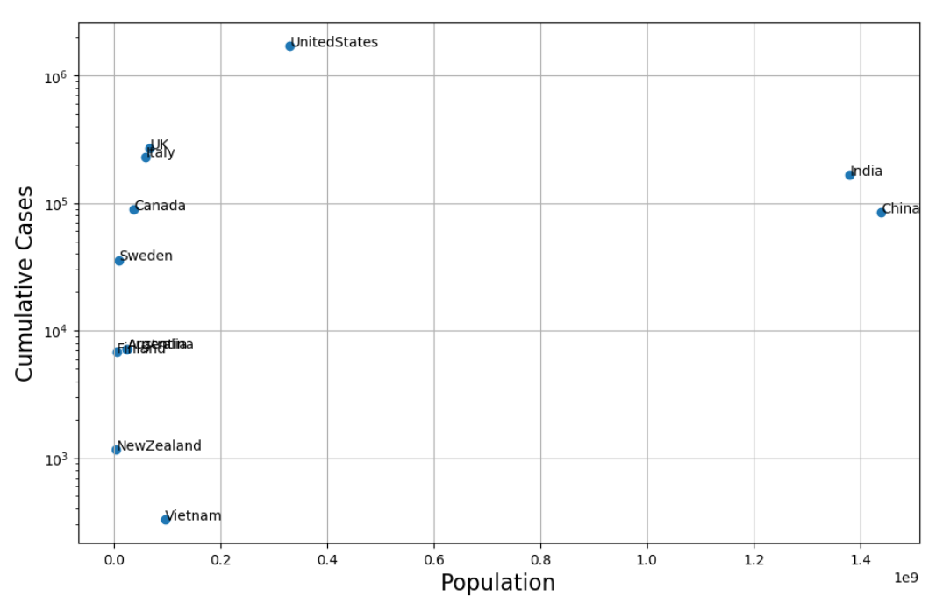

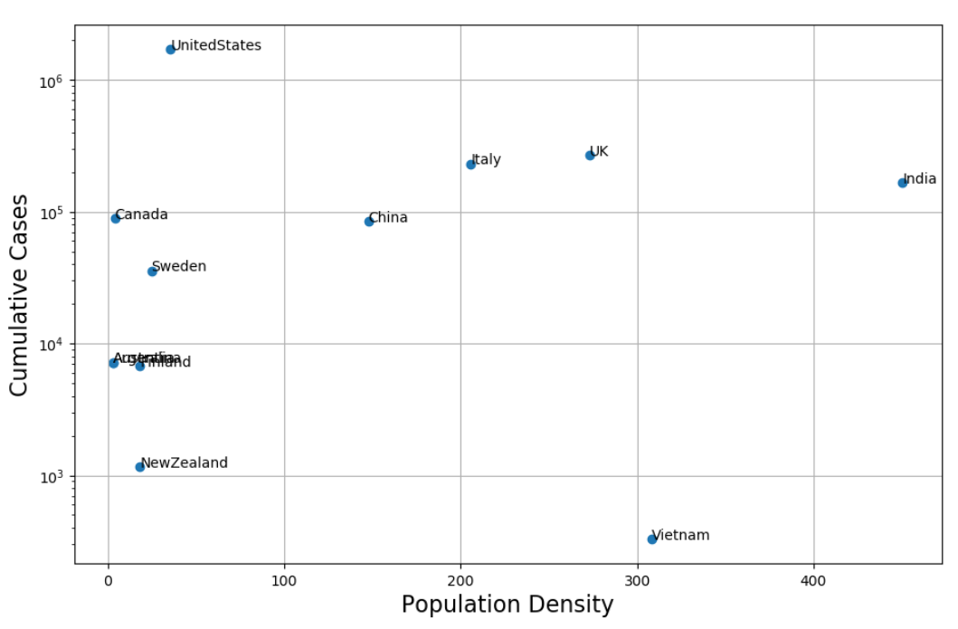

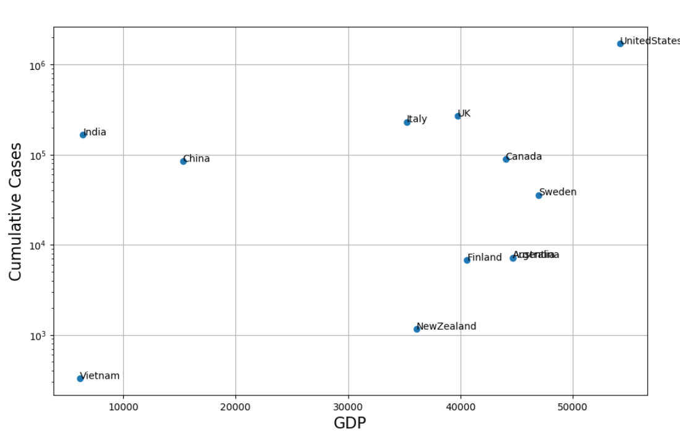

We then created 63 graphs total to look into exact correlations of different factors with total cases.

We started with environmental data provided by NASA, namely - temperature from The POWER Project. We reserved Y coordinate for time, 120 days total, X - both for Total Case (red) and Temperature (blue).

We found the result aligning with our meta study - ambiguous. For China, for example, there is no concrete correlation between Total Cases and Temperature.

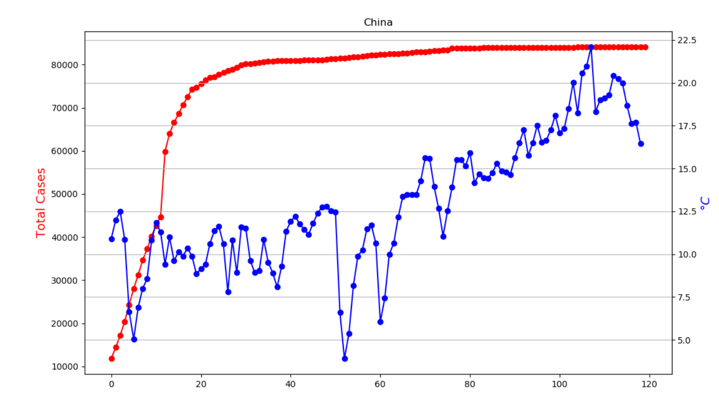

As for Italy - the two are directly dependent. If referring to our meta data, we could make an assumption that temperature could cause an impact on a disease in case rise of temperature is rapid, like in Italy - but most likely other factors should be taken into account.

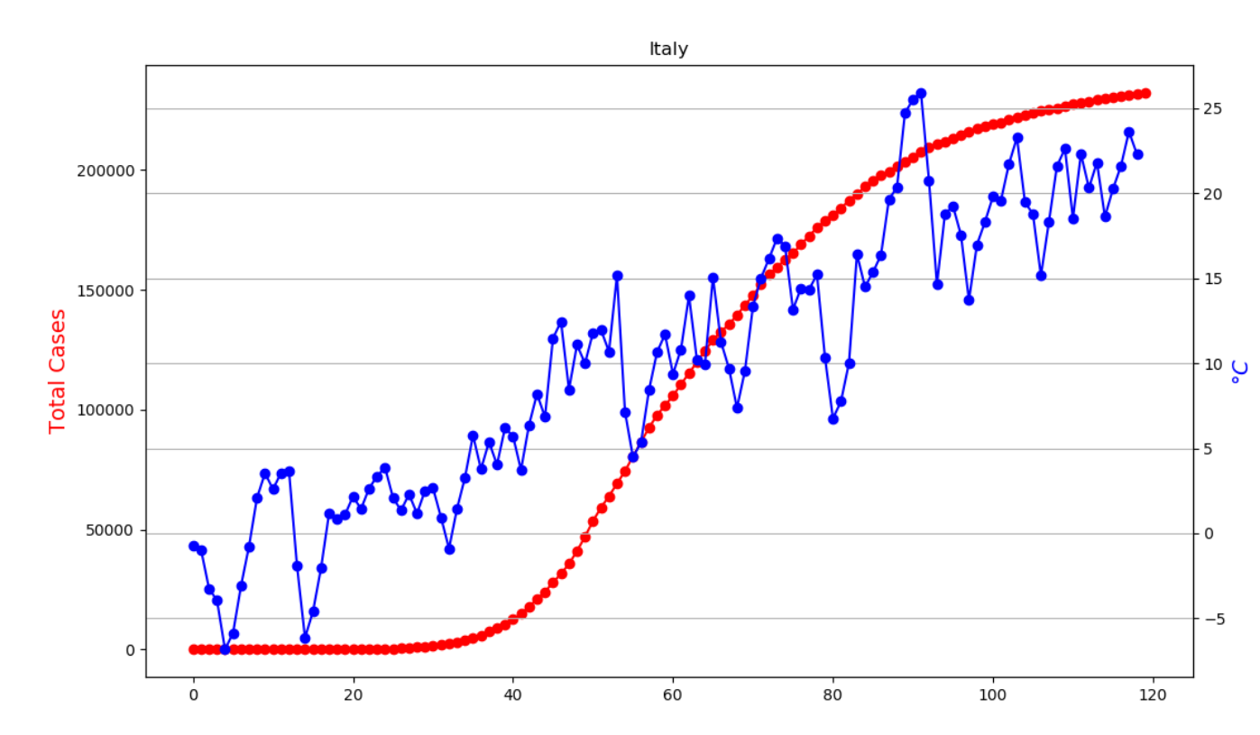

We decided to take a different approach to analyzing measures. We took a country, then applied for groups of measure to them, making a curve on the basis of Difference of consecutive Cumulative Cases (DCCC) we computed. Our assumption was that we would be able to see how efficient different measures were.

For example, we took Vietnam. It showed peaks in DCCC. Provided the closure of public event and testing policies were in place for most of the time, additional implementations of travel bans and workplace closures had a great impact on flattering the peaks. This information is in line with our meta study - the other study have shown that combination of these two policies have a high impact on combating the spread.

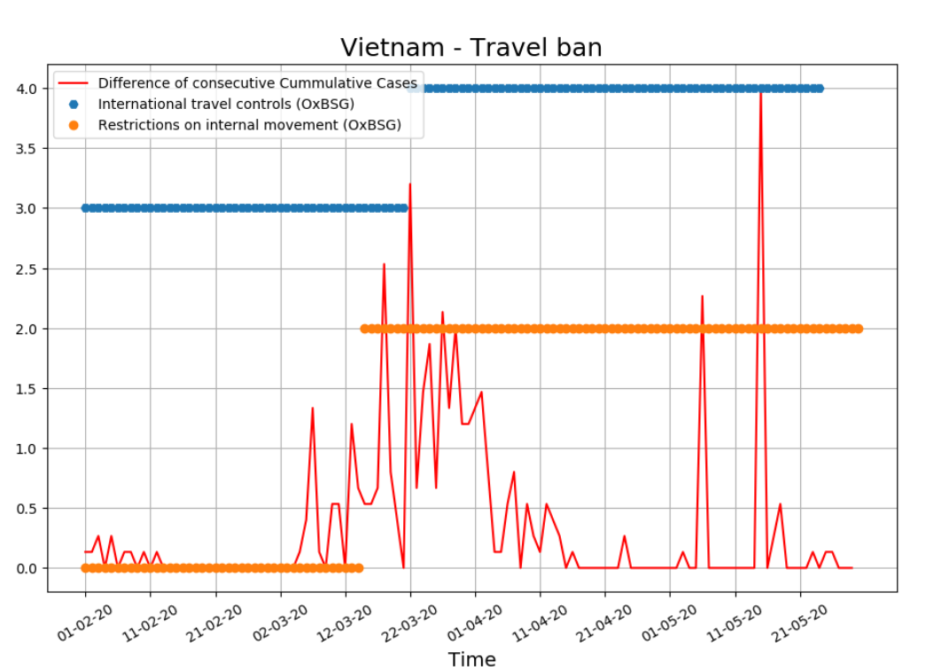

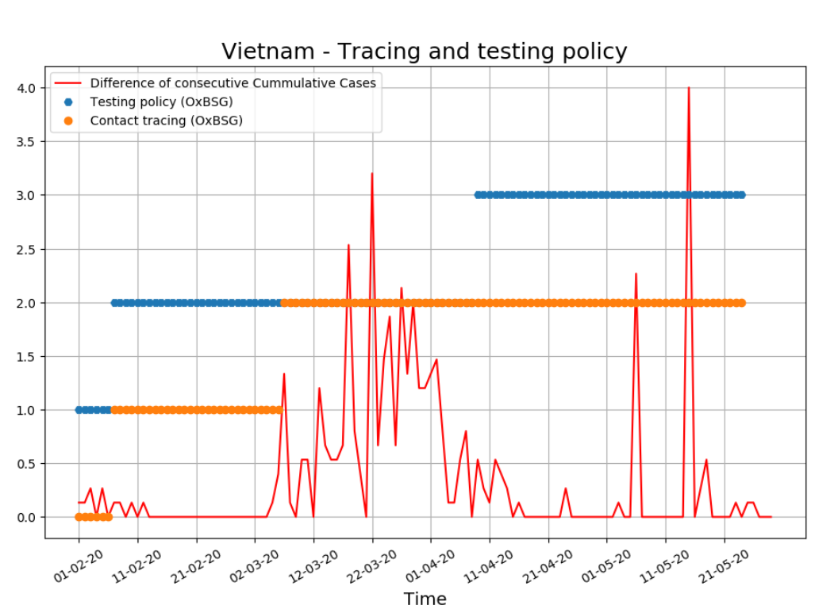

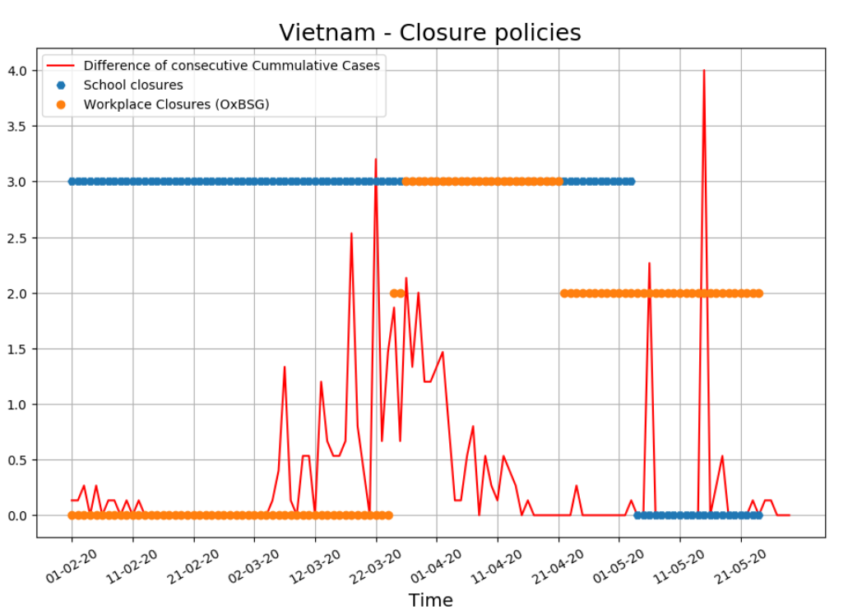

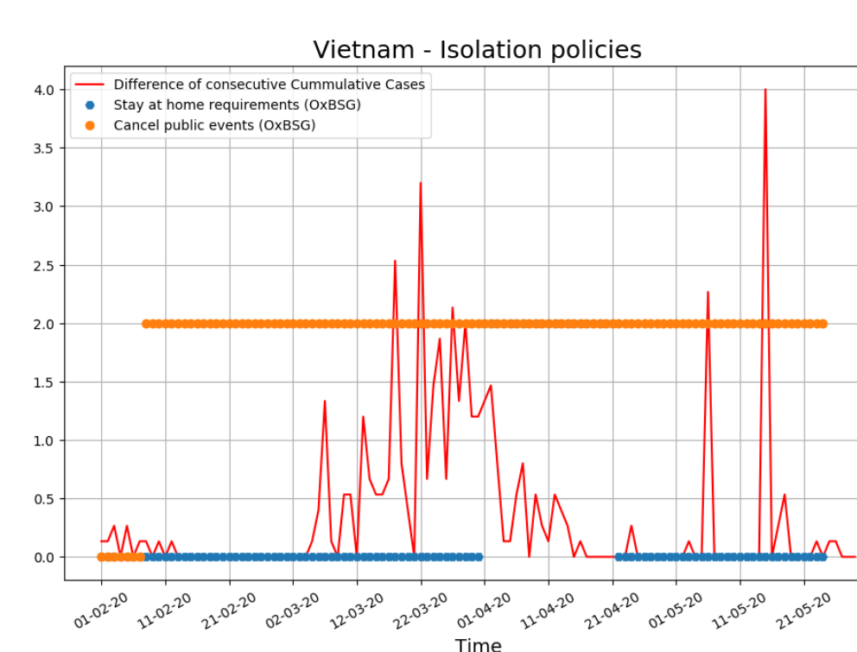

New Zealand, for example, shows that contact tracing and testing could be not effective for fighting peaks, so good enough for maintaining a low curve at a low level at the beginning of the spread. Once again, Workplace closures and Travel Bans shows its efficiency at combating peaks.

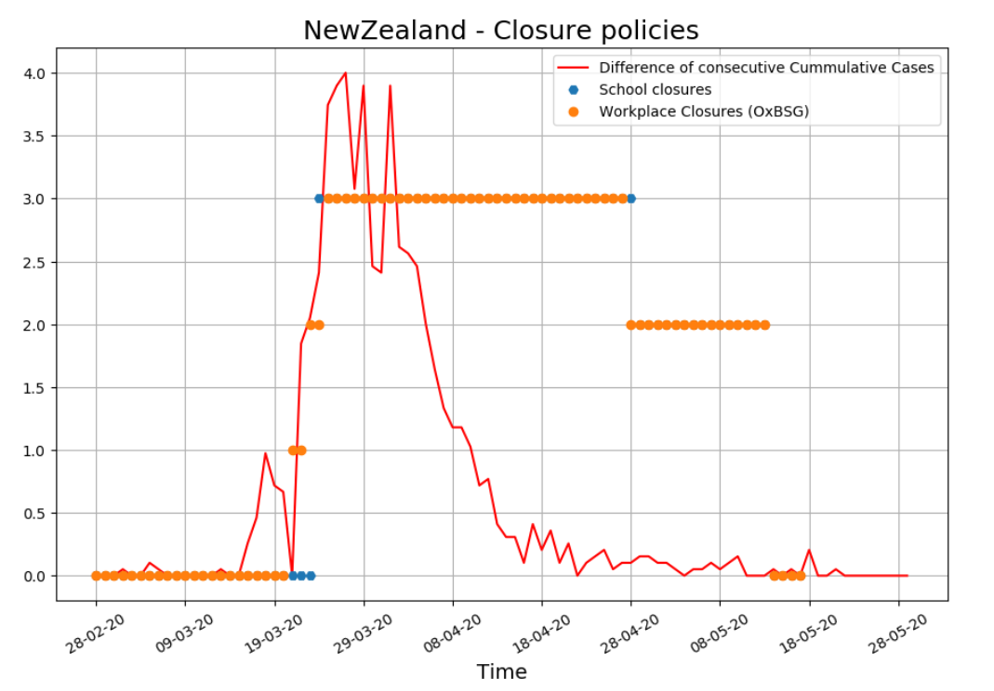

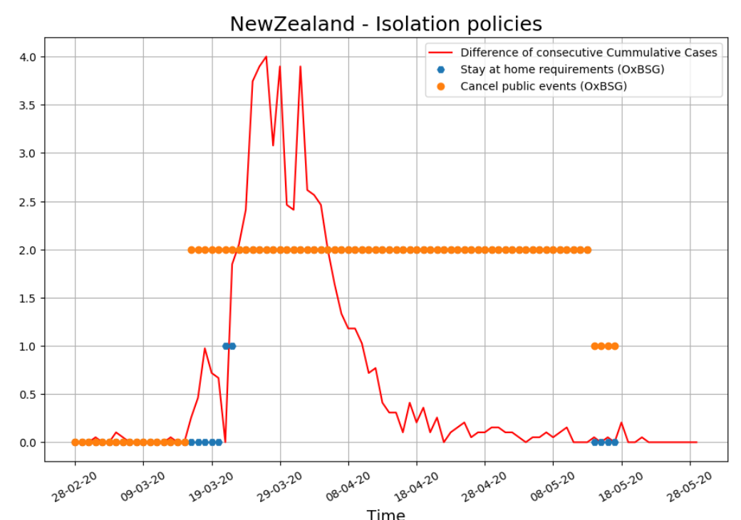

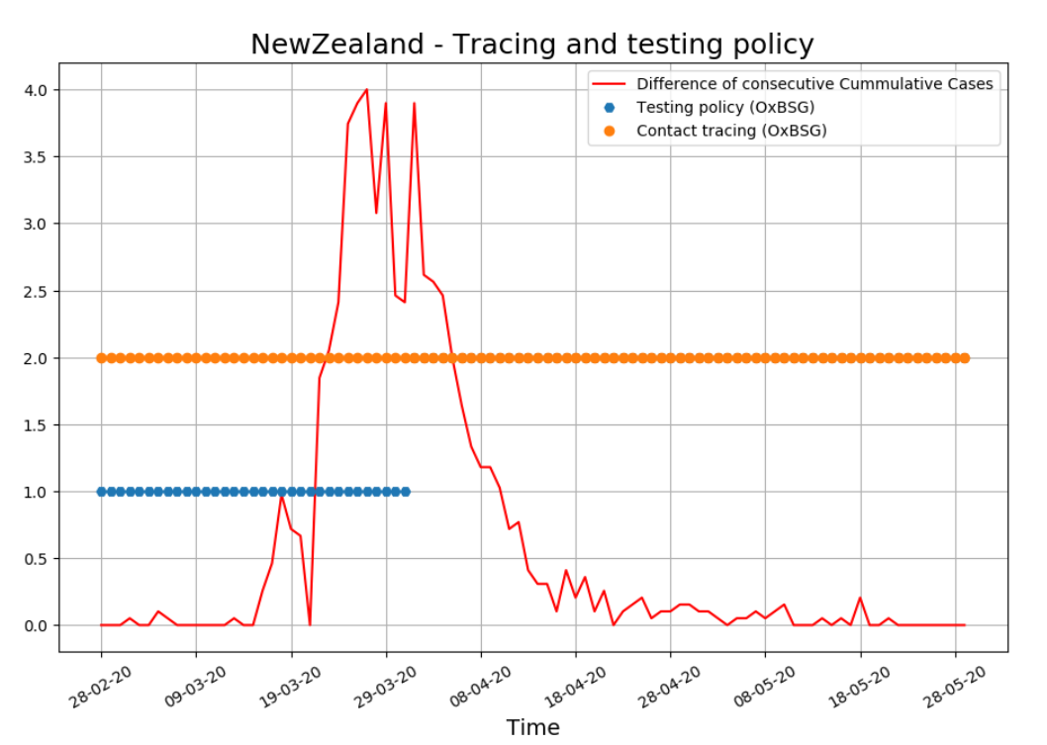

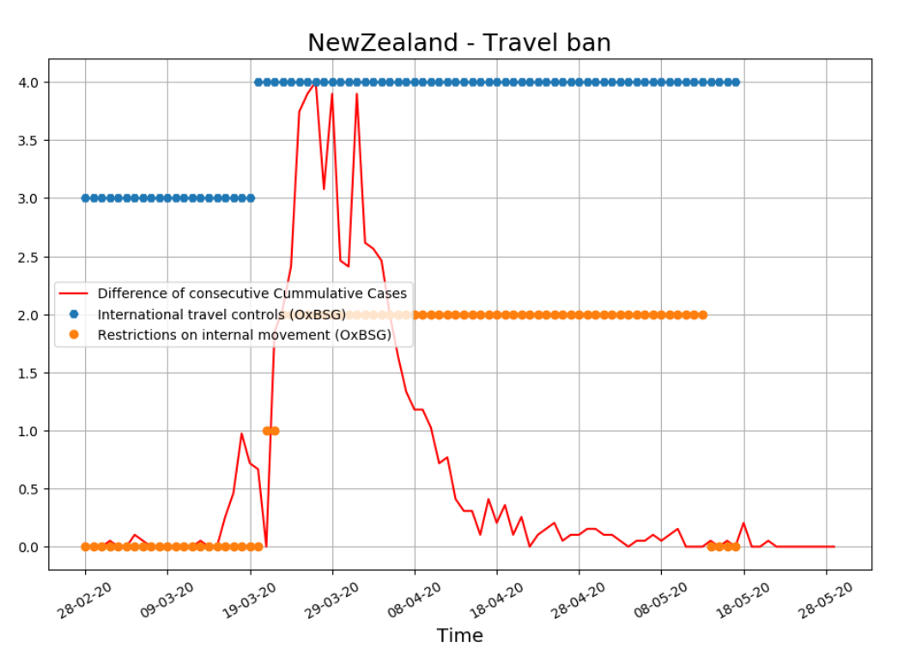

Canada decided to implement tracing and lite international travel control. When the outbreak happened, they managed to apply all the policies at the same time, manage to stop the increase of the disease and hold it on the same level, slowly decreasing over time.

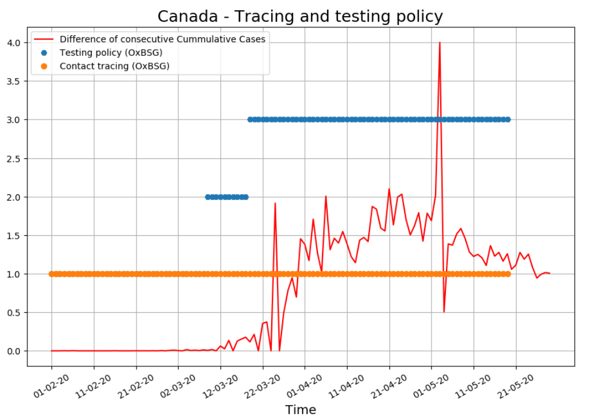

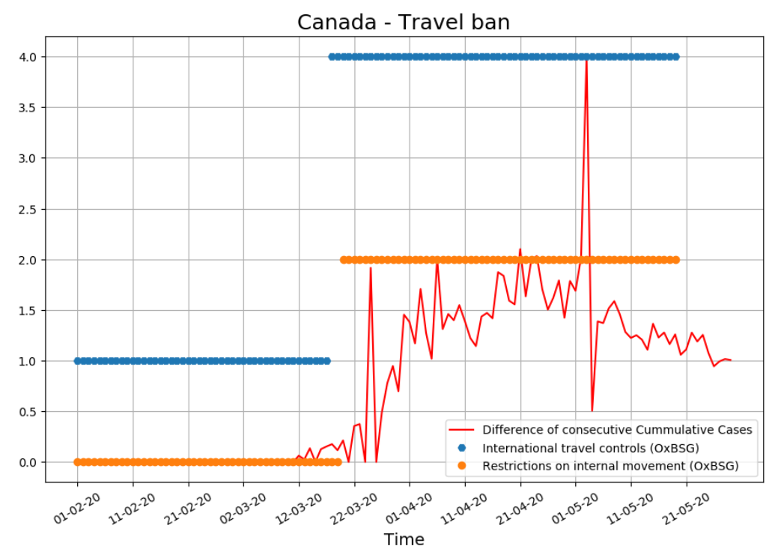

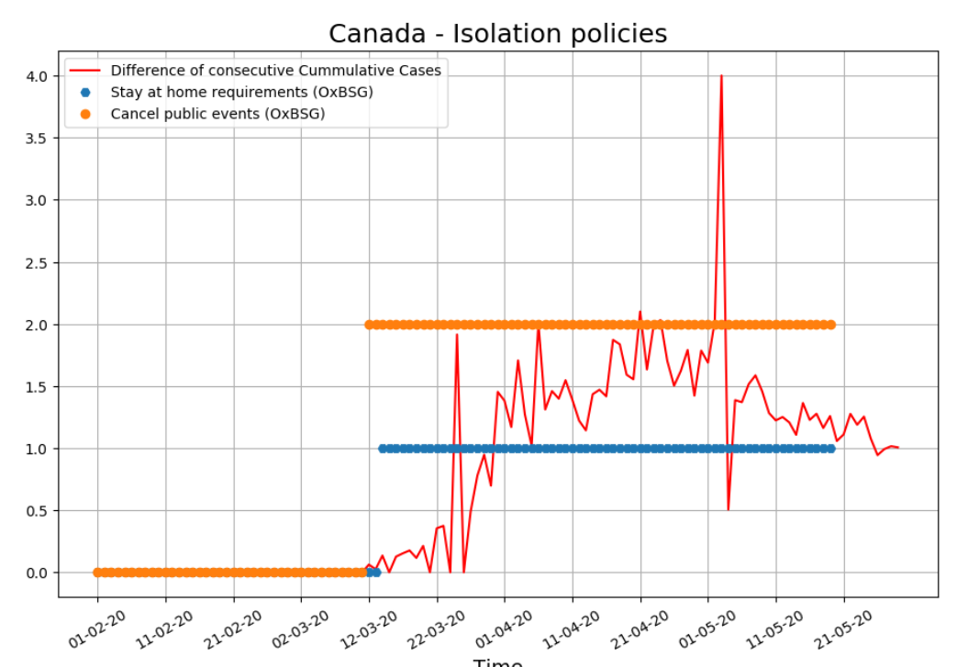

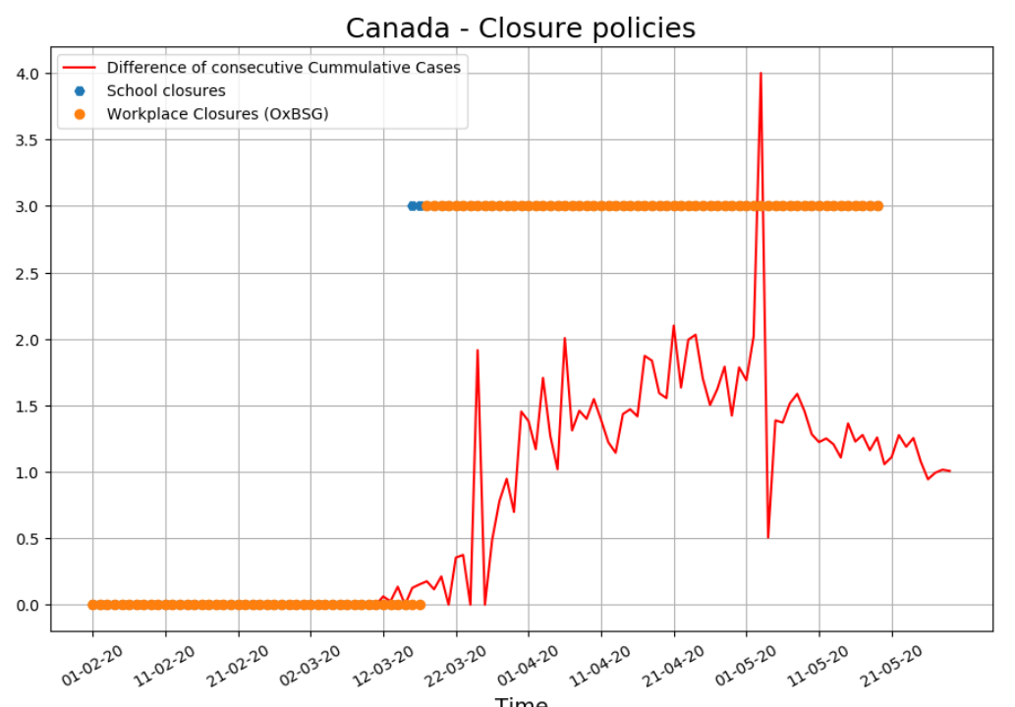

**INTERMEDIATE CONCLUSIONS:**

After analysing all the graphs we made, we could make the following approximate conclusions on effectiveness of different policies:

1. Effective testing and contracting on the very first days of disease spread allows maintaining a curve at a reasonably flat level to have time to prepare for implementation of other measures when peaks strike.
2. After peak strikes, a combination of measures could be applied to maximize efforts. Travel bans in conjunctions with workspace closures show great impact in lowering sudden peaks.
3. Unfortunately, no solid connection was established between temperature and total cases. That is a subject to further analysis.

**5. GUI**

After we made a certain analysis, we needed to put it together and create a prototype of a working solution.

We limited ourselves to basic functionality described at the beginning of our project.

We created a possibility to choose a county a policy maker would like to work with on start of a current cycle of interaction with the programm.

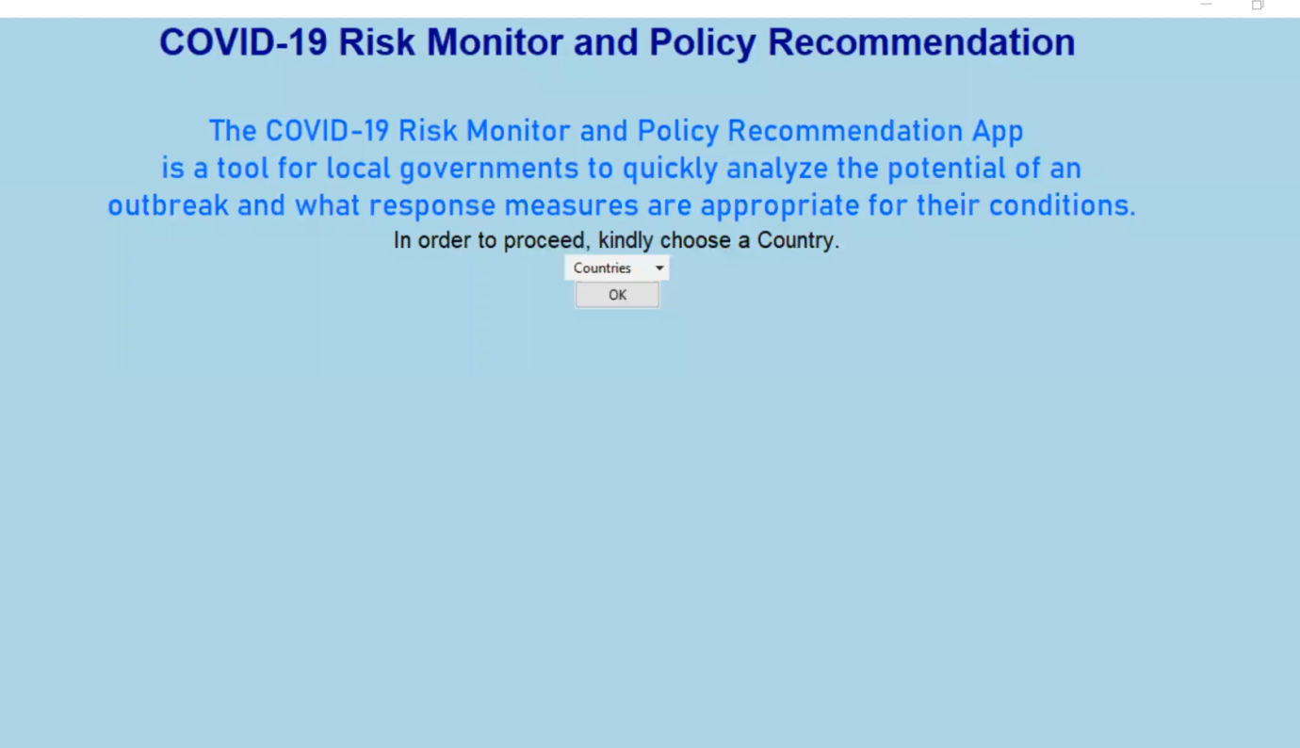

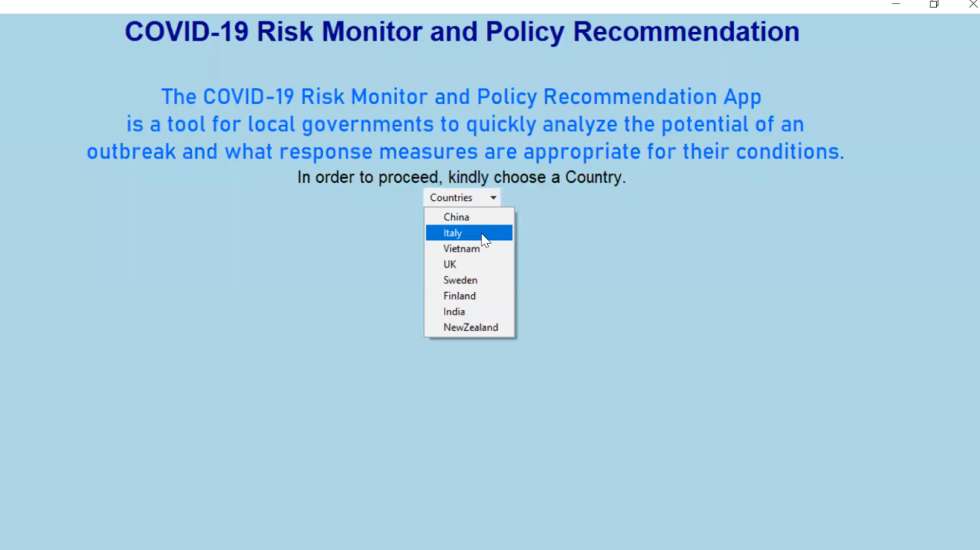

After a country is chosen the user gets an access to a page with an interactive analytical tool to work with different policies` application to the given country. The policies` effectiveness is analysed and provided to the user in an easily comprehensible form. This window is reserved for policy recommendations generation activity also.

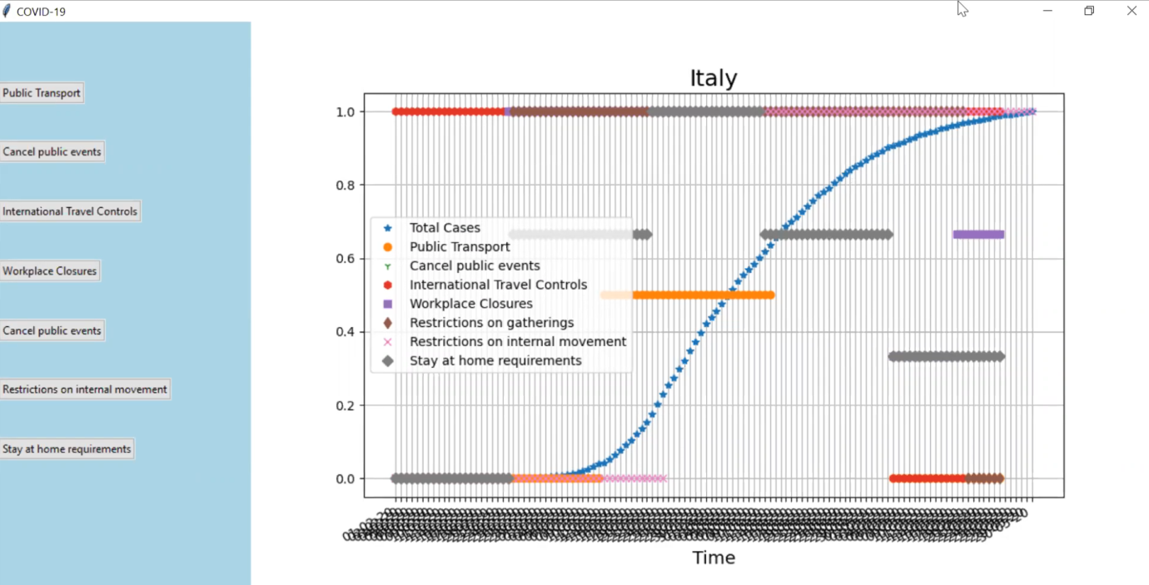

Unfortunately, we had no time to complete the policy recommendations generation tool during HACKATHON weekend, but we are still feal determined to continue our work on the project and make this solution ready to be used by intended users.

**FINAL CONCLUSION:**

Though we haven't implemented all the features we intended to, we evaluated all the assumptions we made in the very beginning and got results that we could use further in our work. We used different types of data and put them together. Finally, we make a certain visualisation of our tools. We find our work during the HACKATHON suttisfying - we have a plan to follow and we would be able to continue working on the project.

Thank you for reading till the end!

Yours,

CODE IN SPACE team

www. codeinspace.co

twitter - @codeinspace3